**Advance Excel Assignment 9**

1. What are the different margins options and do we adjust the margins of the excel worksheet?

Ans. In Excel, page margins are used to specify how much white space (blank area) should be left around the information in your worksheet. This is very similar to how margins are conceived and used in other programs, such as a word processor. Margins are used to provide a visual border for your printed page and an area where the page can be held or bound.

To set margins for a worksheet, choose Page Setup from the File menu. Excel displays the Page Setup dialog box; you should make sure the Margins tab is selected.

* To use predefined margins, click Normal, Wide, or Narrow.
* To specify custom page margins, click Custom Margins and then—in the Top, Bottom, Left, and Right boxes—enter the margin sizes that you want.

1. Set a background for your table created.

Ans. 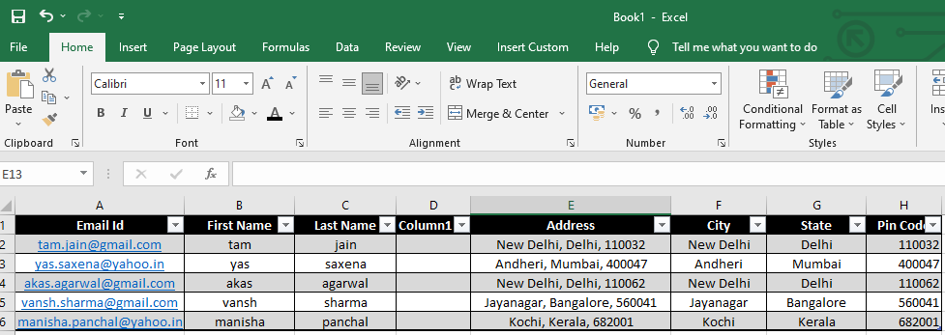

1. What is freeze panes and why do we use freeze panes? Give examples.

Ans. To keep an area of a worksheet visible while you scroll to another area of the worksheet, go to the View tab, where you can Freeze Panes to lock specific rows and columns in place, or you can Split panes to create separate windows of the same worksheet.

Freeze rows or columns:

Freeze the first column

* Select View > Freeze Panes > Freeze First Column.

            The faint line that appears between Column A and B shows that the first column is frozen.

Freeze the first two columns

* Select the third column.
* Select View > Freeze Panes > Freeze Panes.

Freeze columns and rows

* Select the cell below the rows and to the right of the columns you want to keep visible when you scroll.
* Select View > Freeze Panes > Freeze Panes.

Unfreeze rows or columns

* On the View tab > Window > Unfreeze Panes.

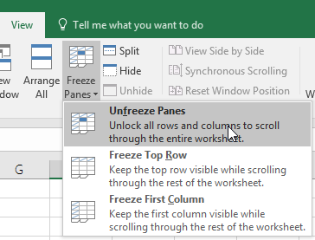

1. What are the different features available within the Freeze Panes command?

Ans. Excel enables three methods to freeze the pane.

* Freeze Pane
* Freeze Top Row
* Freeze First Column

Properties of freeze pane:

* Once the worksheet is frozen using the freeze pane feature, you cannot unfreeze the worksheet by undoing the action. You have to unfreeze it manually.
* If you freeze the top row, only the first row of the sheet will be frozen. You cannot freeze the column at the same time.
* Similar to Point No. 2, if you freeze the first column using Freeze First Column, only the first column of the worksheet will be frozen. You cannot freeze the row at the same time.
* If you apply the Freeze Pane option of Excel freeze pane feature, it can freeze the row and column simultaneously at the same time.

1. Explain what the different sheet options present in excel are and what they do?

Ans. Microsoft Excel is currently the most powerful spreadsheet software developed by Microsoft. It allows us to organize vast amounts of data across multiple sheets. Every Excel workbook has at least one sheet. By default, when we create a new Excel file, it usually has three sheets, namely Sheet1, Sheet2, and Sheet3. Furthermore, we can add or delete the desired number of sheets accordingly.

What is a Sheet in Excel?

An Excel sheet, also called a worksheet, is a single page or a document in an Excel workbook with the collection of cells to help us organize the data. Based on requirements, an Excel workbook can have many sheets. The sheets are typically listed as tabs and are accessed from the bottom of the Excel window.

What are the sheet options in Excel?

Since an Excel sheet is one of the core elements of the workbook, there are multiple core options to perform from the Sheet Options. We can access various sheet options by using the following ways:

* Ribbon Sheet Options
* Right-click Sheet Options